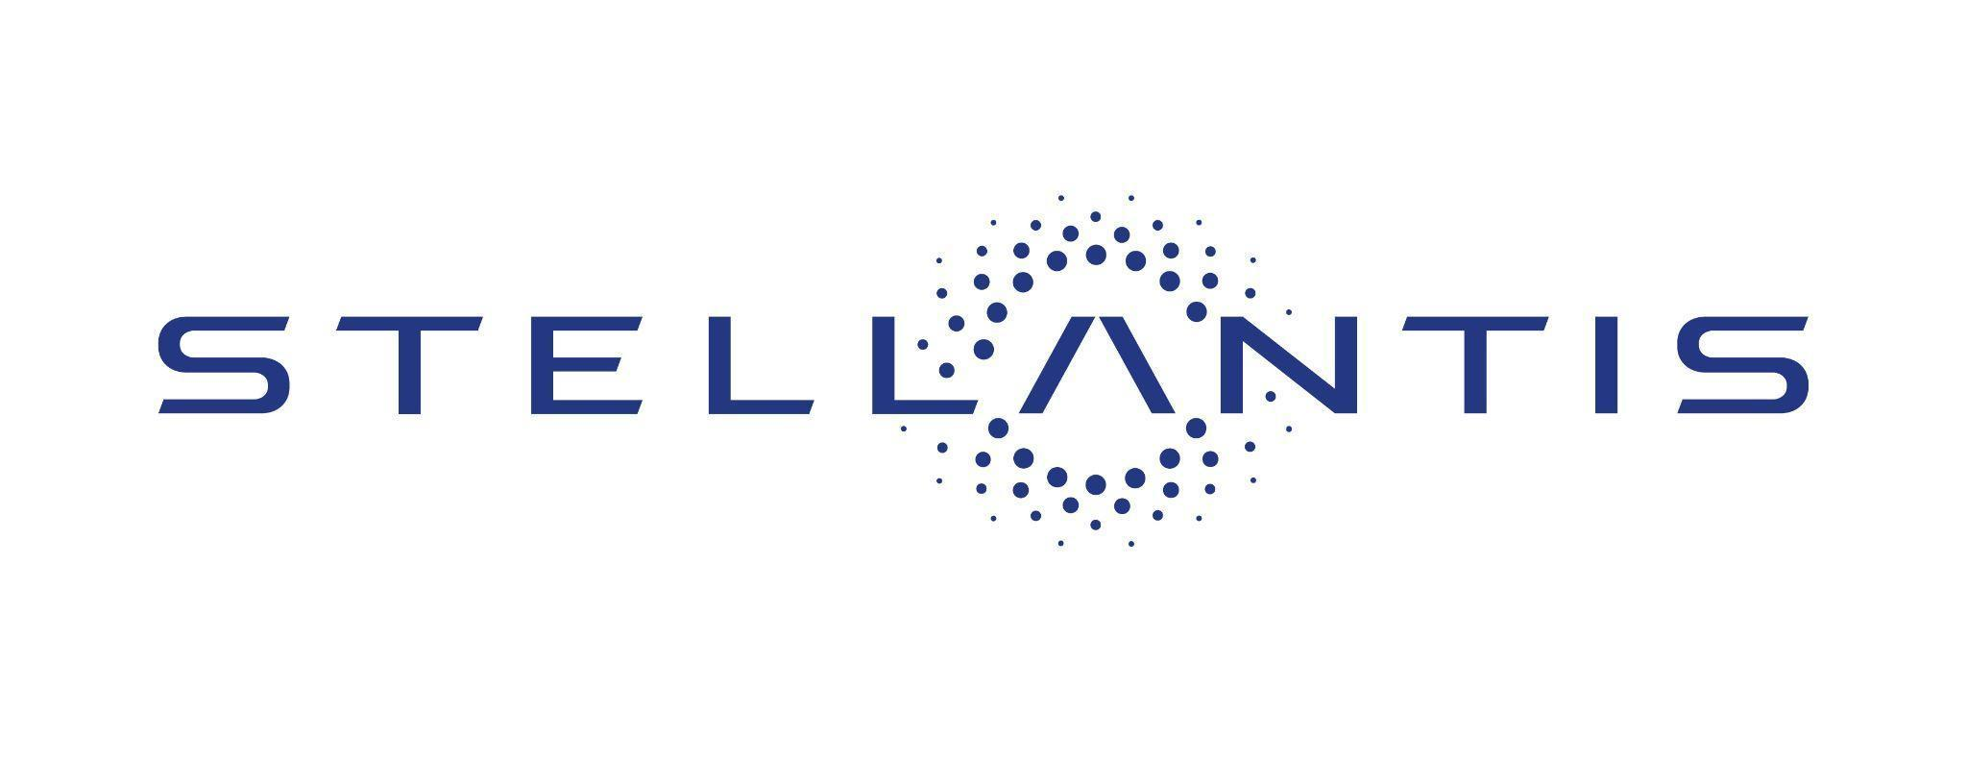

Stellantis Signals Its Continued Confidence in Archer by Further Increasing Its Strategic Shareholding in the Company

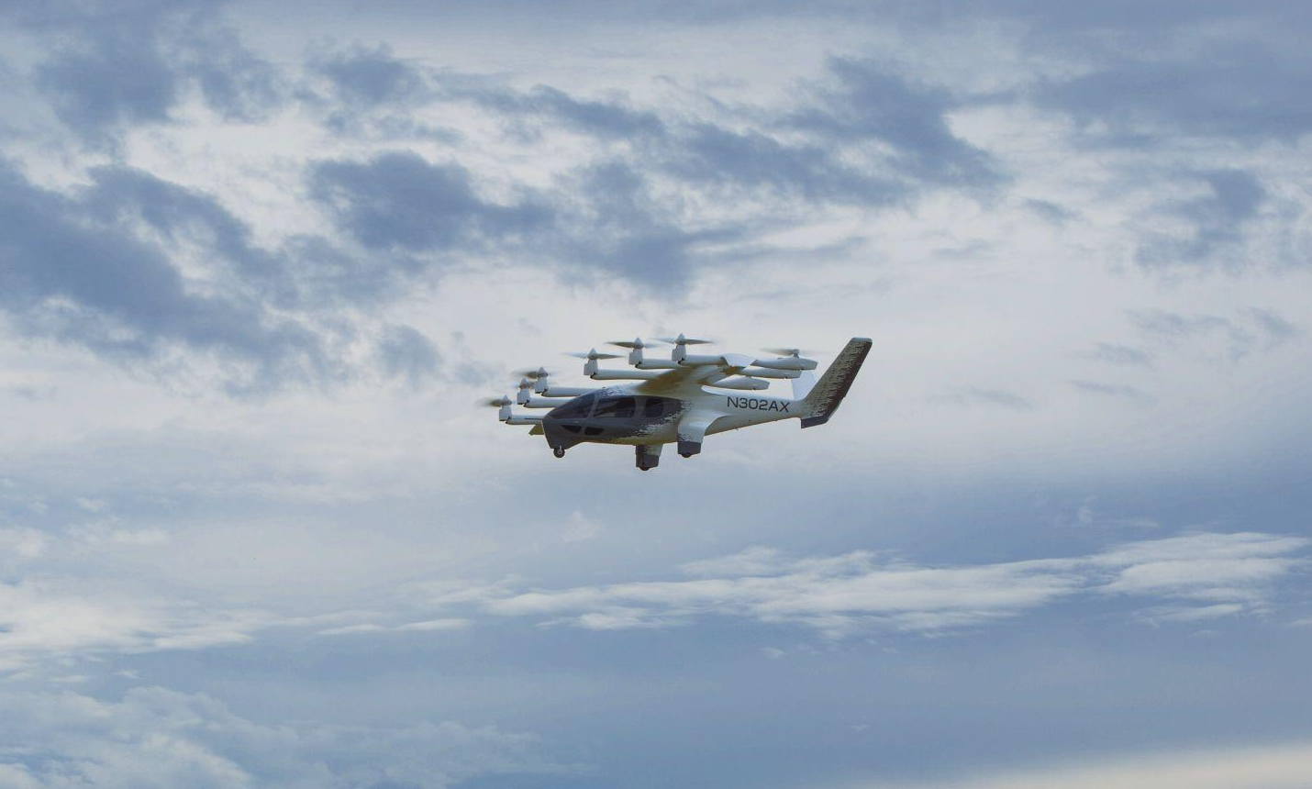

Stellantis completes a series of open market purchases of ~8.3 million shares

AMSTERDAM AND SANTA CLARA, CALIFORNIA, March 18, 2024 – Stellantis N.V. and Archer Aviation Inc. (NYSE: ACHR) today announced that Stellantis recently completed a series of open market purchases of ~8.3 million shares of Archer’s stock signaling Stellantis’ continued confidence in Archer’s plans to bring electric vertical take-off and landing (eVTOL) aircraft to market beginning in 2025. Stellantis’ increased investment in Archer follows CEO Carlos Tavares’ recent visit to Archer’s headquarters and manufacturing facilities in Santa Clara, California.

In January 2023, Stellantis announced that its goal was for Stellantis to mass produce Archer’s Midnight aircraft as its exclusive contract manufacturer thereby allowing Archer to strengthen its path to commercialization by helping it avoid hundreds of millions of dollars of spending. The construction on the first phase of Archer’s high-volume manufacturing facility in Georgia remains on track to be completed later this year. The first phase is a build out of ~350,000 square feet on a ~100 acre site designed to support production of up to 650 aircraft annually, which would make it one of the largest manufacturing facilities by volume in the aircraft industry.

Archer’s Midnight aircraft is designed to be safe, sustainable, quiet and carry four passengers plus a pilot. Midnight is optimized for back-to-back short distance trips of around 20-50 miles, with a charging time of approximately 10 minutes in-between.

“Archer has established itself as a market leader in the electrification of aviation and we believe that together we can usher in the next transportation revolution,” said Stellantis CEO Carlos Tavares. “This recent move by Stellantis signals our confidence in Archer’s team and the progress we see firsthand through our deep partnership.”

“We are on the cusp of changing the way the world moves in the sky,” said Adam Goldstein, founder and CEO of Archer. “Archer and Stellantis are working side by side to realize a once-in-a-generation opportunity to redefine urban transportation and deliver tremendous value to the world’s cities and our shareholders.”

Stellantis has been a strategic partner to Archer since 2020 through various collaboration initiatives, and as an investor since 2021. During this time, Archer has leveraged Stellantis’ deep manufacturing, supply chain, and design expertise in connection with Archer’s efforts to design, develop, and commercialize its eVTOL aircraft.

# # #

About Stellantis

Stellantis N.V. (NYSE: STLA / Euronext Milan: STLAM / Euronext Paris: STLAP) is one of the world’s leading automakers aiming to provide clean, safe and affordable freedom of mobility to all. It’s best known for its unique portfolio of iconic and innovative brands including Abarth, Alfa Romeo, Chrysler, Citroën, Dodge, DS Automobiles, Fiat, Jeep®, Lancia, Maserati, Opel, Peugeot, Ram, Vauxhall, Free2move and Leasys. Stellantis is executing its Dare Forward 2030, a bold strategic plan that paves the way to achieve the ambitious target of becoming a carbon net zero mobility tech company by 2038, with single-digit percentage compensation of the remaining emissions, while creating added value for all stakeholders. For more information, visit www.stellantis.com

About Archer

Archer is designing and developing electric vertical takeoff and landing aircraft for use in urban air mobility networks. Archer’s mission is to unlock the skies, freeing everyone to reimagine how they move and spend time. Archer’s team is based in Santa Clara, CA.

To learn more, visit www.archer.com.

Stellantis Media Contacts

Fernão SILVEIRA +31 6 43 25 43 41 – fernao.silveira@stellantis.com
Shawn MORGAN +1 248 760 2621 – shawn.morgan@stellantis.com

Archer Media Contacts

The Brand Amp - Archer@TheBrandAmp.com

Archer Forward-Looking Statements
This press release contains forward-looking statements regarding Archer’s future business plans and product roadmaps, and the expected timing thereof, including statements regarding the development, commercialization, and manufacturing of Archer’s eVTOL aircraft, such as the timeline for commercialization of Archer’s eVTOL aircraft. These forward looking statements are only predictions and may differ materially from actual results due to a variety of factors. The risks and uncertainties that could cause actual results to differ from the results predicted are more fully detailed under the caption “Risk Factors” in Archer’s Annual Report on Form 10-K for the year ended December 31, 2023, as well as other documents filed by Archer from time to time with the Securities and Exchange Commission (SEC) available on the SEC website at www.sec.gov. In addition, please note that any forward looking statements contained herein are based on assumptions that Archer believes to be reasonable as of the date of this press release. Archer undertakes no obligation to update these statements as a result of new information or future events.

Stellantis Forward-Looking Statements
This communication contains forward-looking statements. In particular, statements regarding future events and anticipated results of operations, business strategies, the anticipated benefits of the proposed transaction, future financial and operating results, the anticipated closing date for the proposed transaction and other anticipated aspects of our operations or operating results are forward-looking statements. These statements may include terms such as “may”, “will”, “expect”, “could”, “should”, “intend”, “estimate”, “anticipate”, “believe”, “remain”, “on track”, “design”, “target”, “objective”, “goal”, “forecast”, “projection”, “outlook”, “prospects”, “plan”, or similar terms. Forward-looking statements are not guarantees of future performance. Rather, they are based on Stellantis’ current state of knowledge, future expectations and projections about future events and are by their nature, subject to inherent risks and uncertainties. They relate to events and depend on circumstances that may or may not occur or exist in the future and, as such, undue reliance should not be placed on them.

Actual results may differ materially from those expressed in forward-looking statements as a result of a variety of factors, including: the ability of Stellantis to launch new products successfully and to maintain vehicle shipment volumes; changes in the global financial markets, general economic environment and changes in demand for automotive products, which is subject to cyclicality; Stellantis’ ability to successfully manage the industry-wide transition from internal combustion engines to full electrification; Stellantis’ ability to offer innovative, attractive products and to develop, manufacture and sell vehicles with advanced features including enhanced electrification, connectivity and autonomous-driving characteristics; Stellantis’ ability to produce or procure electric batteries with competitive performance, cost and at required volumes; Stellantis’ ability to successfully launch new businesses and integrate acquisitions; a significant malfunction, disruption or security breach compromising information technology systems or the electronic control systems contained in Stellantis’ vehicles; exchange rate fluctuations, interest rate changes, credit risk and other market risks; increases in costs, disruptions of supply or shortages of raw materials, parts, components and systems used in Stellantis’ vehicles; changes in local economic and political conditions; changes in trade policy, the imposition of global and regional tariffs or tariffs targeted to the automotive industry, the enactment of tax reforms or other changes in tax laws and regulations; the level of governmental economic incentives available to support the adoption of battery electric vehicles; the impact of increasingly stringent regulations regarding fuel efficiency requirements and reduced greenhouse gas and tailpipe emissions; various types of claims, lawsuits, governmental investigations and other contingencies, including product liability and warranty claims and environmental claims, investigations and lawsuits; material operating expenditures in relation to compliance with environmental, health and safety regulations; the level of competition in the automotive industry, which may increase due to consolidation and new entrants; Stellantis’ ability to attract and retain experienced management and employees; exposure to shortfalls in the funding of Stellantis’ defined benefit pension plans; Stellantis’ ability to provide or arrange for access to adequate financing for dealers and retail customers and associated risks related to the operations of financial services companies; Stellantis’ ability to access funding to execute its business plan; Stellantis’ ability to realize anticipated benefits from joint venture arrangements; disruptions arising from political, social and economic instability; risks associated with Stellantis’ relationships with employees, dealers and suppliers; Stellantis’ ability to maintain effective internal controls over financial reporting; developments in labor and industrial relations and developments in applicable labor laws; earthquakes or other disasters; risks and other items described in Stellantis’ Annual Report on Form 20-F for the year ended December 31, 2023 and Current Reports on Form 6-K and amendments thereto filed with the SEC; and other risks and uncertainties.

Any forward-looking statements contained in this communication speak only as of the date of this document and Stellantis disclaims any obligation to update or revise publicly forward-looking statements. Further information concerning Stellantis and its businesses, including factors that could materially affect Stellantis’ financial results, is included in Stellantis’ reports and filings with the U.S. Securities and Exchange Commission and AFM.

